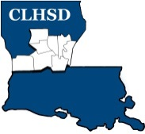
Central Louisiana Human Services District
Board Meeting Agenda
January 7, 2021

- Call to Order/Quorum
- Prayer/Pledge

- Read and Approve January 2021 Meeting Agenda (Vote)
Solicit Public Comment Requests

- Approval of Minutes (Vote)

December 2020 Board Meeting Minutes

- District Reports

  - Financial Report- (Vote) H1

  - ED Monthly Report H2

- Policy Reviews

Executive Limits:

  - II. D. Financial Planning/Budgeting w/corresponding procedure – Non Appropriated Funds - H3

- Board Business
  - Comments Collected on ED Performance
  - Board Development/Training Topic –Mental Health Court

- Questions/Comments as Solicited

- Next Month – February

  - Executive Limits – ED
- II.E. Financial Condition and Activities w/procedure Non Appropriated Funds

  - Board Business
- Members Term Wishes send to Parishes/ Governor’s Office
- Annual Bylaws Review

  - Training Topic – Residential Treatment

- Announcements
Next meeting – February 4, 2020

- Adjourn (Vote)

